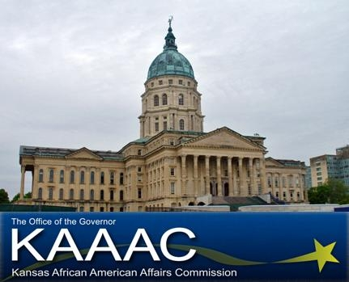 | Kansas  African American Youth Day:  Quest for the Best!  March 22, 2011  Topeka, KS

Application for Volunteers
Please print or type

Personal Information

Name: _________________________________________________
Last First

Address: _____________________________________________________________

City: ___________________________ State: ___________ ZIP: _______________

Date of Birth: _______________________

Home Phone: (_____)________________ Work Phone: (_____)________________

Fax Number: (_____)_______________ E-mail: _____________________________

Qualifications

Education: ____________________________________________________________

______________________________________________________________________

______________________________________________________________________

______________________________________________________________________

______________________________________________________________________

Work/Volunteer Experience: _____________________________________________

______________________________________________________________________

______________________________________________________________________

______________________________________________________________________

Abilities/Strengths: _____________________________________________________

______________________________________________________________________

______________________________________________________________________

______________________________________________________________________

Other Qualifications: ___________________________________________________

______________________________________________________________________

______________________________________________________________________

______________________________________________________________________

References (please provide 2 references)

Name: ______________________________________________

Address: _____________________________________________________________

City: ___________________________ State: ___________ ZIP: _______________

Phone Number: (_____)_______________ E-mail: ___________________________

Name: ______________________________________________

Address: _____________________________________________________________

City: ___________________________ State: ___________ ZIP: _______________

Phone Number: (_____)_______________ E-mail: ___________________________

Please explain your interest in volunteering for AAYD:

____________________________________________________________

____________________________________________________________

____________________________________________________________

____________________________________________________________

Please circle your t-shirt size: Small Medium Large X-Large XX-Large
Other (please specify): ___________________

Signature: _________________________________ Date: _____________________

Please send completed application to:

Kansas African American Affairs Commission
900 SW Jackson - Suite 101
Topeka, KS 66612
785-296-4874 Office
785-296-1795 Fax

Or email:
shawn.bryant@ks.gov

All volunteer applications are DUE by March 11, 2011.

